**Stability of Lunar Lagrange Point L2**

**Conor Diver | Durham University | 9th November 2020**

There are 5 stationary solutions for the circular restricted 3 body problem known as the 5 Lagrange points of an orbit.

The restricted 3 body problem involves 2 massive objects of masses $M_{1}$ and $M_{2}$ on fixed circular orbits around a common centre of mass, and a third object with negligible mass, $m$, moving within the system’s gravitational potential.

The stationary points arise at points in space where the distance between $m$ and both of $M_{1}$ and $M_{2}$ remains constant throughout time. For this to be true, the orbital period of the third body with negligible mass must be equal to that of the 2 massive body orbital system. In the rotating frame with $ω=\frac{2π}{P}$, the total force on the third body is:

$$F = -G(\frac{M_{1}m}{{r_{1}}^{2}}\hat{r_{1}}+\frac{M_{2}m}{{r_{2}}^{2}}\hat{r_{2}}) - mrω^{2} (1)$$

Which gives an effective gravitational potential (in the rotating frame $ω=\frac{2π}{P}$) of:

$$ϕ=-G(\frac{M_{1}}{r_{1}}+\frac{M_{2}}{r_{2}}) - \frac{1}{2}r^{2}ω^{2} (2)$$

The Lagrange points are represented by the stationary solutions in space, which are when[1]:

There are at least 3 of these “unstable” stationary points in any system – L1, L2, L3 – and an additional 2 “stable” stationary points – L4, L5 – when the condition $\frac{M_{1}}{M_{2}}>24.96$ is met.

**Lagrange Points**

Introducing a negligible mass rocket to the system can be used to test the stability of a Lagrange point – specifically L2 which lies past the moon on the Moon-Earth axis.

An estimation of the distance from the moon required can be obtained from the following equation[2]:

With the rocket placed at this position, and given an initial velocity perpendicular to the Moon-Earth axis:

$$v=rω=r\frac{2π}{P}$$

The rocket will orbit the Moon-Earth system, maintaining a constant distance from both the Moon and the Earth, in the unstable L2 position.

**Earth-Moon 3 Body Problem**

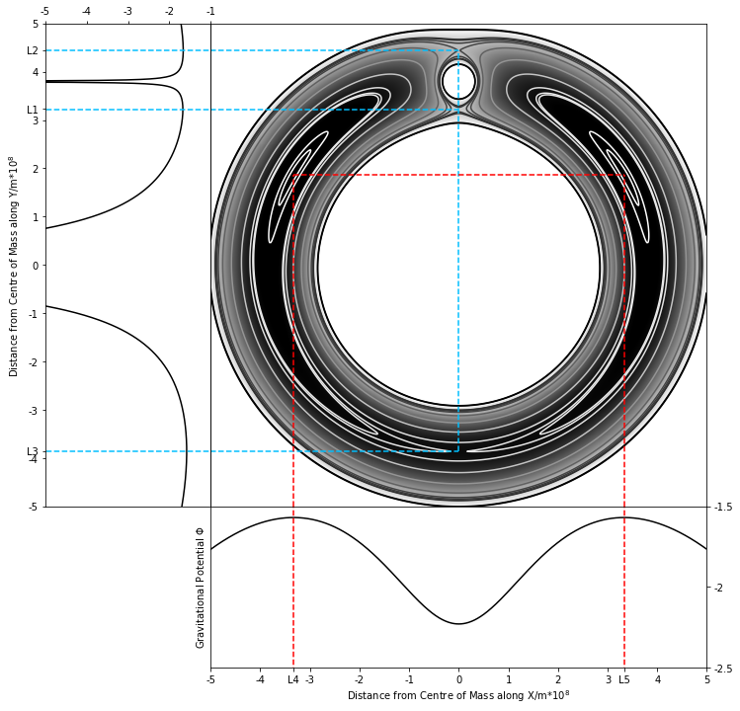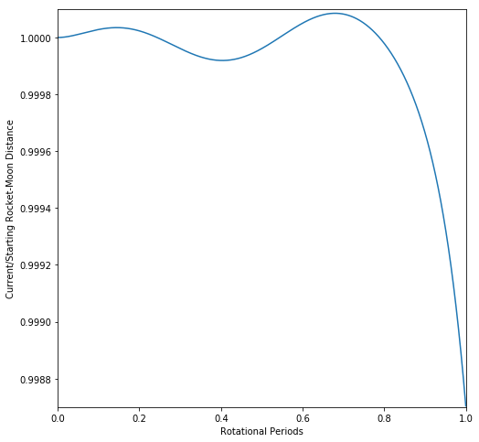­­ ­­

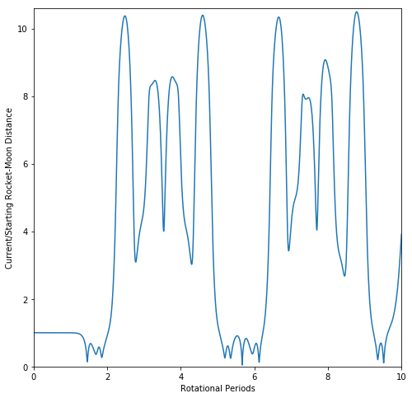

The Earth-Moon orbital system meets the conditions for all 5 Lagrange points, with a mass ratio of $\frac{M_{1}}{M_{2}}=81.$ 28. L1, L2, and L3 are shown by saddle point contours, and correspond to the maxima of the gravitational potential in space along the x=0. L4 and L5 are shown by contour maxima, and correspond to gravitational potential maxima along y=1.87e8.

**FIG.1: Earth-Moon Gravitational System**

At an initial distance of $∆r=$ 64522900*m*, the orbit of the rocket remained mostly stable for the first period – remaining between 1.0001 and 0.9987 times the initial $∆r$. However, as time progresses the rocket begins to leave the unstable L2 zone and spirals out of a stationary orbit. It begins to loop around the Moon between periods 1 and 2, and then proceeds to enter a close Earth orbit for an additional 3 periods. This clearly shows the instability of the L2 point – that even a small perturbation of $≈1\%$ can lead to departure from the orbit after only 1 full orbital period.

**FIG.2: Rocket-Moon Distance Over Time**

The initial distance used, $∆r=$ 64522900*m*, is approximately 6% larger than the value suggested in equation **(4)**. This is expected, as the equation provides an estimation of the position of L2. The stability of the orbit is extremely sensitive to even slight perturbations from the optimal position, hence deviation from the estimate is required for a stable orbit.

The initial fluctuations in the first orbital period, as shown in **FIG.2**, suggest that more precision is required when simulating the orbits of the Earth, Moon, and rocket. A smaller time step between gravitational simulations will provide a more continuous path for the rocket to follow and reduce deviation of the rocket from the rocket-Moon distance. However, if the initial proximity of the rocket to the L2 point is not sufficiently accurate, the rocket will still spiral out of a stable orbit as time goes on.

**Discussion Of Results**

References: [1] Tipler, *Modern Physics*, 6th edition, W.H. Freeman (2012), Pages 62-65 **|** [2] *The Lagrange Points*, 2012, WMAP, [map.gsfc.nasa.gov/ContentMedia/lagrange.pdf] as of Nov 2020